**Opgave 3 i canvas**

1. Skriv koden, der genererer nedenstående gradient:

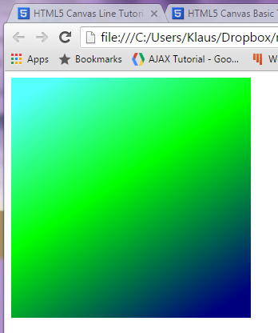

1. Skriv koden, der genererer nedenstående gradient:

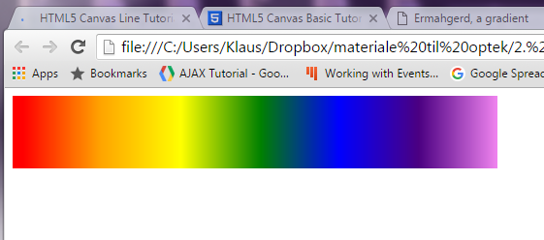

1. Skriv koden, som genererer lastbilen:

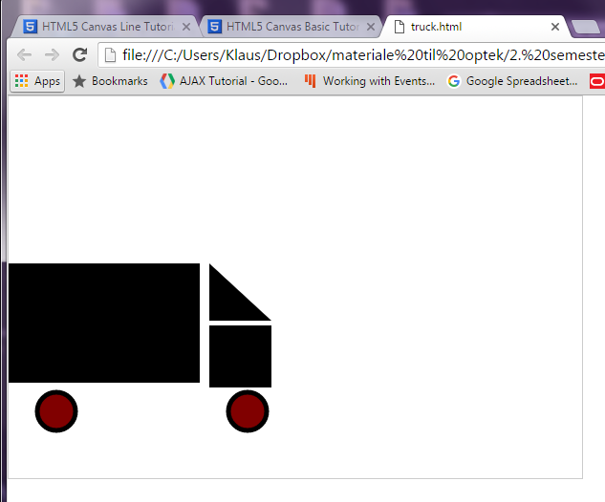

Her er lidt hjælp:

1. Create a canvas that is 600 by 400 pixels.
2. Draw a square at *x* and *y* coordinates 210 and 240 with a width and height of 65. Fill the square black.
3. Draw a rectangle at *x* and *y* coordinates 0 and 175 with a width of 200 and height of 125. Fill the rectangle black.
4. Draw a triangle that starts at coordinates 210,175. The second coordinate is 275,235, the third coordinate is 210,235, and the final coordinate takes you back to the starting position: 0,175. Fill the triangle black.
5. Draw two circles. The first circle has an *x* value of 250, a *y* value of 330, and a radius of 20. The second circle has an *x* value of 50, a *y* value of 330, and a radius of 20. The fill color for both circles should be #800000, and the stroke color should be black. The line should be 5 pixels.

You should now be able to see the vehicle drawn by the coordinates given above